Genalex 1946 Portable model 888
By Graham Parslow

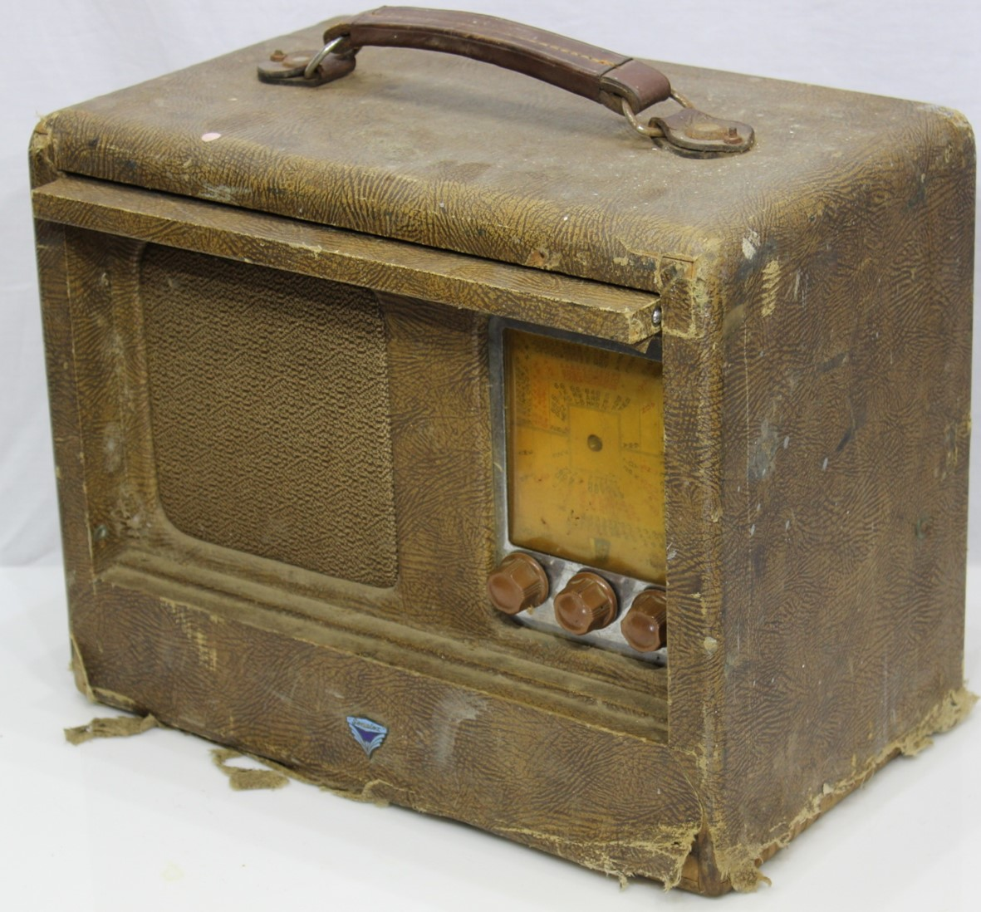

Was this radio a bargain at $10? The value was realised by making it a restoration project. This radio also prompted research into the history of British General Electric in Australia. The ARTS&P decal dates this radio to post WWII and the model 888 circuit appears in the 1946 AORSM compilation. Tasma were the manufacturers of Genalex products from 1930 to 1953 and the model 888 radio was also marketed with a Tasma badge.
The Circuit
The circuitry is pre-war featuring all octal valve types. The triple gang tuning capacitor supports an RF amplification stage using a 1N5 valve. The 1N5 RF-amplifier has a metal skirt that is earthed as a shield although the valve may have been manufactured with a full metal shield like the subsequent valves. Only the output pentode is unshielded. The familiar GOAT shield was US patented, but the light weight shields used here are stamped only with N.Z. and Australian patent numbers. If you know more about who made these shields please submit your information to Radio Waves.

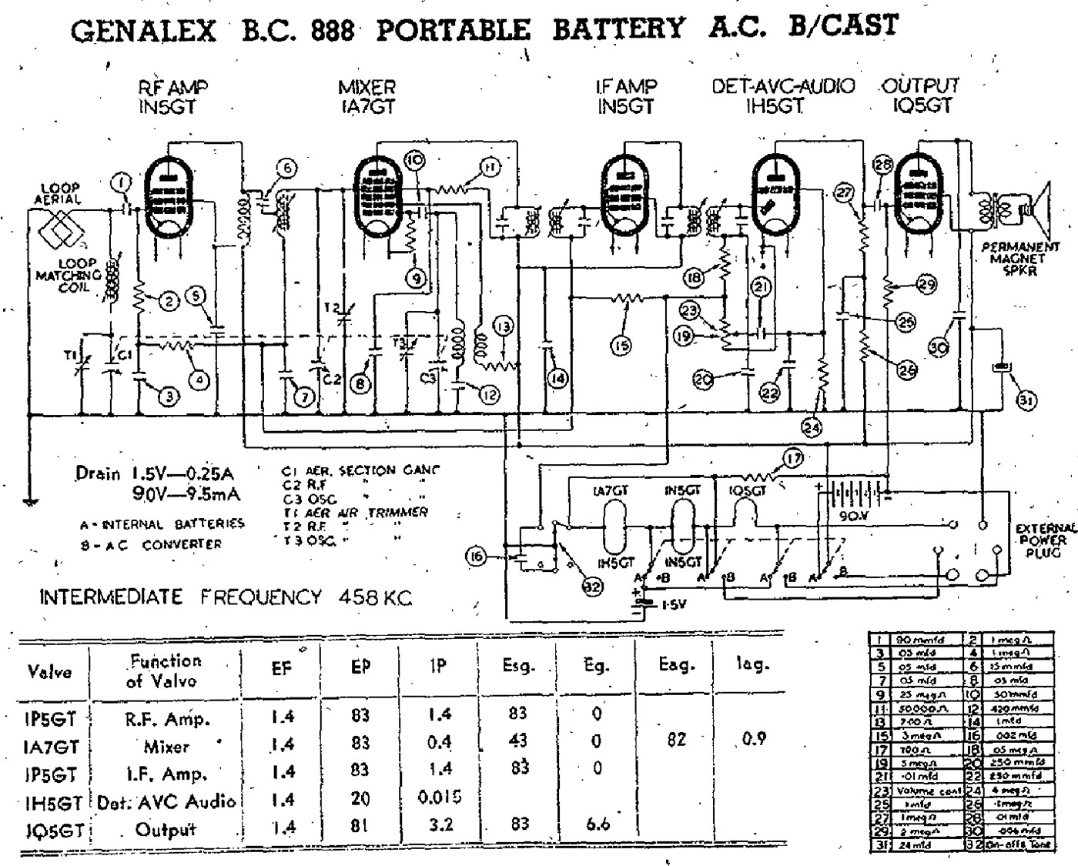
The loop aerial is neatly wound into a rebate towards the back of the cabinet. The leatherette fabric covers the aerial. However, this radio had lost the fabric on the base so the aerial was revealed. Unusually the provision for external connections are adjacent to the carrying handle. The leather anchors at each end of the handle show a thread and nut coming from the case. These are not part of the handle, but provide connection points for an external aerial and earth. The internal aerial detaches from the radio by releasing spring clips.
Stations are selected by the tuned circuit formed by the first tuning capacitor gang and the aerial loop. Amplified RF is then passed to the 1A7 mixer by a coupling transformer mounted under the chassis in a rectangular shielded case. The secondary of this coupling transformer can be tuned by a slug that protrudes from the rear of the chassis (it can be seen in the middle of the mounting threads for the shield can). The coupling transformer forms a tuned circuit with the second gang of the tuning capacitor to enhance selectivity. The local oscillator is tuned by the third gang of the tuning capacitor and the oscillator coil can be seen under the chassis covered with red wax. The IF frequency is a little unusual at 458 kHz, but the stage is quite conventional with two IF transformers mounted on the top of the chassis.
The detector has a single diode to provide AGC and audio output. The audio is fed from a 0.5M volume control to the triode grid of the 1H5. The tone switch has two positions that connects a 0.002uF top-cut capacitor between earth and the top of the volume control when bass is selected. The other tone position has no function other than to disconnect the top-cut.
The speaker is an Amplion 5 inch permanent magnet unit with a 12k Ohm transformer attached. The leads from the output transformer primary are detachable from connecting-posts on the chassis.
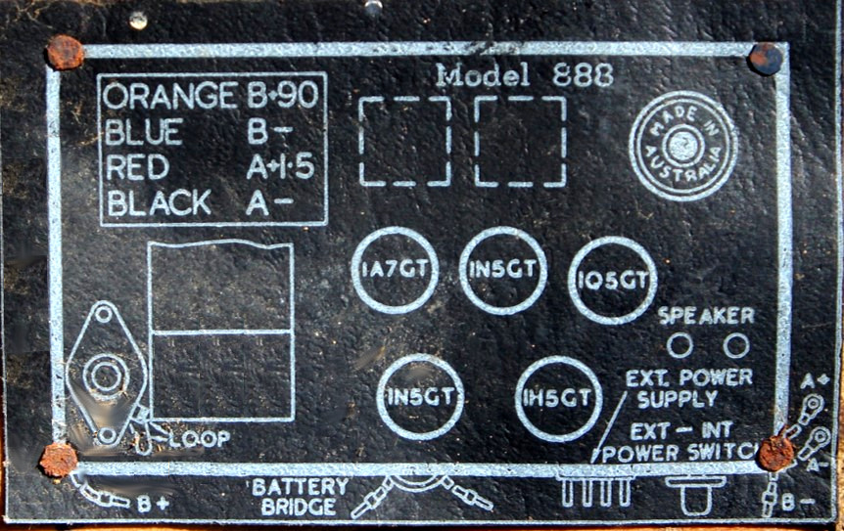
In battery mode the power selector joins all valve filaments in parallel to be driven by 1.5 V.

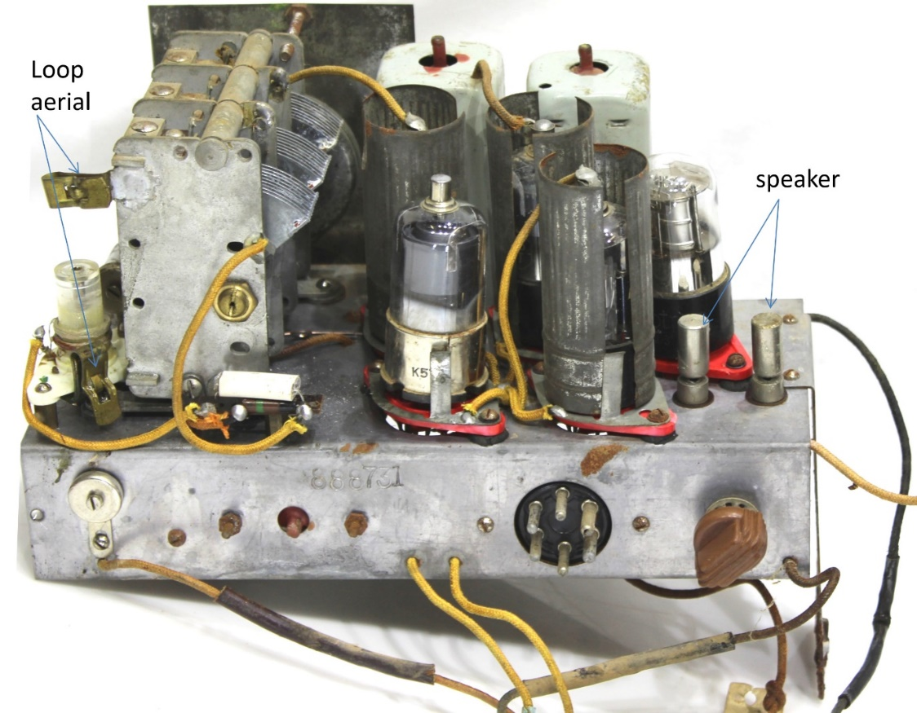
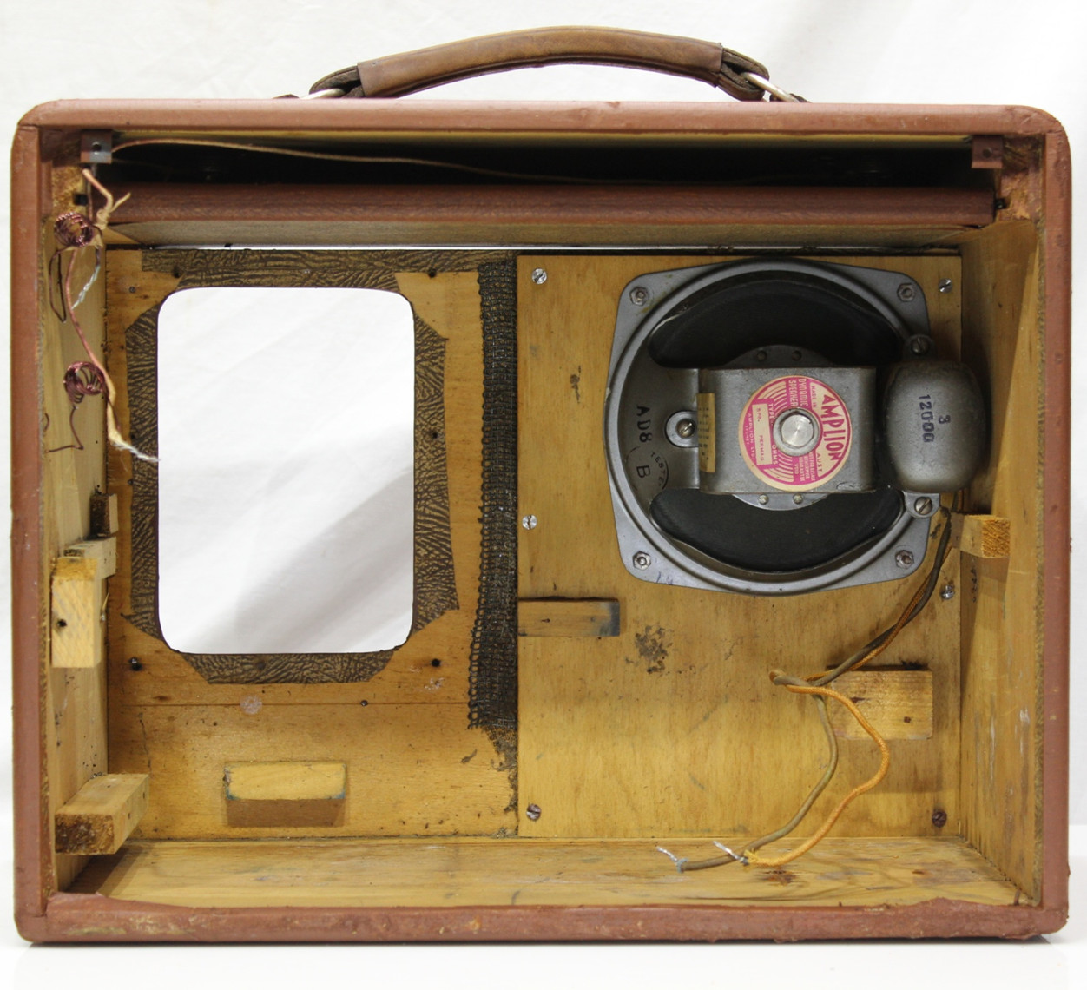
Restoration
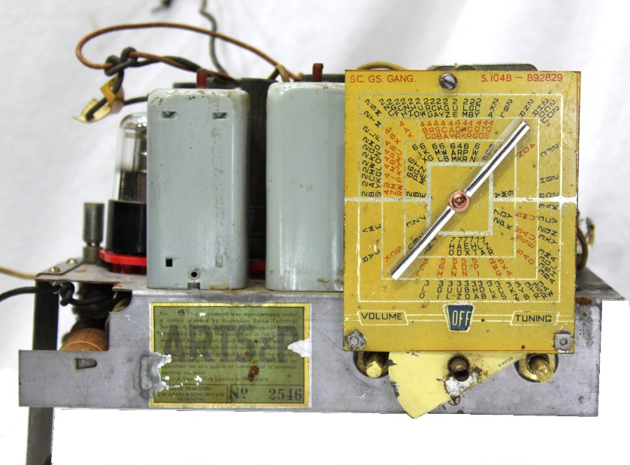
The dial pointer was missing so a replacement was created using automotive chrome strips attached to a clear plastic backing.
Before anything else the primary of the output transformer was checked for continuity and the analogue meter test produced the correct resistance and a crackle in the speaker.
The HT filter electrolytic C31 was replaced before powering up. The large old Aerovox electrolytic was blocking access to the 1Q5 valve socket so replacing it made it possible to work in this area (essential as it turned out).

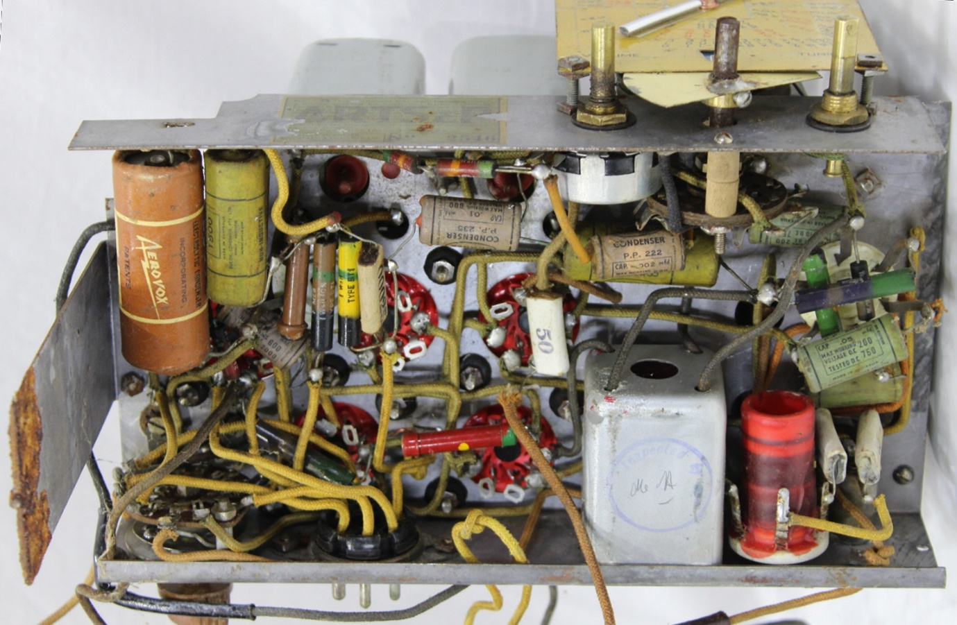
At first connecting bench power supplies to the battery leads resulted in nothing happening with no current drawn by either LT or HT. Both the ON-OFF switch at the front and the power selector switch at the rear had failed. Persistence with CRC contact cleaner eventually produced good contact of the battery lines.
Four of the valves have filaments rated to draw 50mA and the 1Q5 is rated at 100mA. In theory this adds to 300mA drawn from a 1.5V source. The circuit diagram states filament drain as 250mA and may have been measured with a battery producing less than 1.5V on load. With a digitally measured supply voltage of 1.5 this radio had a filament current of 278mA, close enough to the expected value. However, ramping up the HT from zero resulted in 15mA drawn at 56 V and no radio function beyond a faint hum in the speaker. Since a 10mA draw was expected at 90V it was time to halt and find the cause of the excessive loading. No components under the chassis were noticeably heating. Measuring voltages at the 1Q5 showed the grid bias was +2.1 V easily explaining the high current draw and lack of function of the output amplifier. The plate of the 1H5 triode measured a mere 22V with a DMM so the 1H5 would not have been providing much amplification to any audio. The HT limiting resistor R27 (1 M) measured 1.25M and was replaced. The lack of function and high current can be explained by the combination of R27 going high and a leaky audio-coupling capacitor C28 (0.01uF) making the 1Q5 positively biased at the grid. Sometimes theory and practice do coincide, and this was such an occasion. A replacement R27 and C28 brought the set to life drawing 9 mA at 90 V. The grid bias improved to -7.5 V at the 1Q5 and 66 V was measured at the 1H5 plate. The 1H5 plate voltage of 20 V given on the circuit diagram is seriously misleading because it is the result of an analogue meter (probably 20 kΩ/volt) shunting current to earth.
This was a chassis of intermediate difficulty to work on. Thankfully the chassis was stable on the bench either when completely inverted or on its side as in the photograph. Setting the Leader signal generator to 458kHz established that the IF alignment was optimal. Reception was excellent from this five valve portable using only the loop aerial.
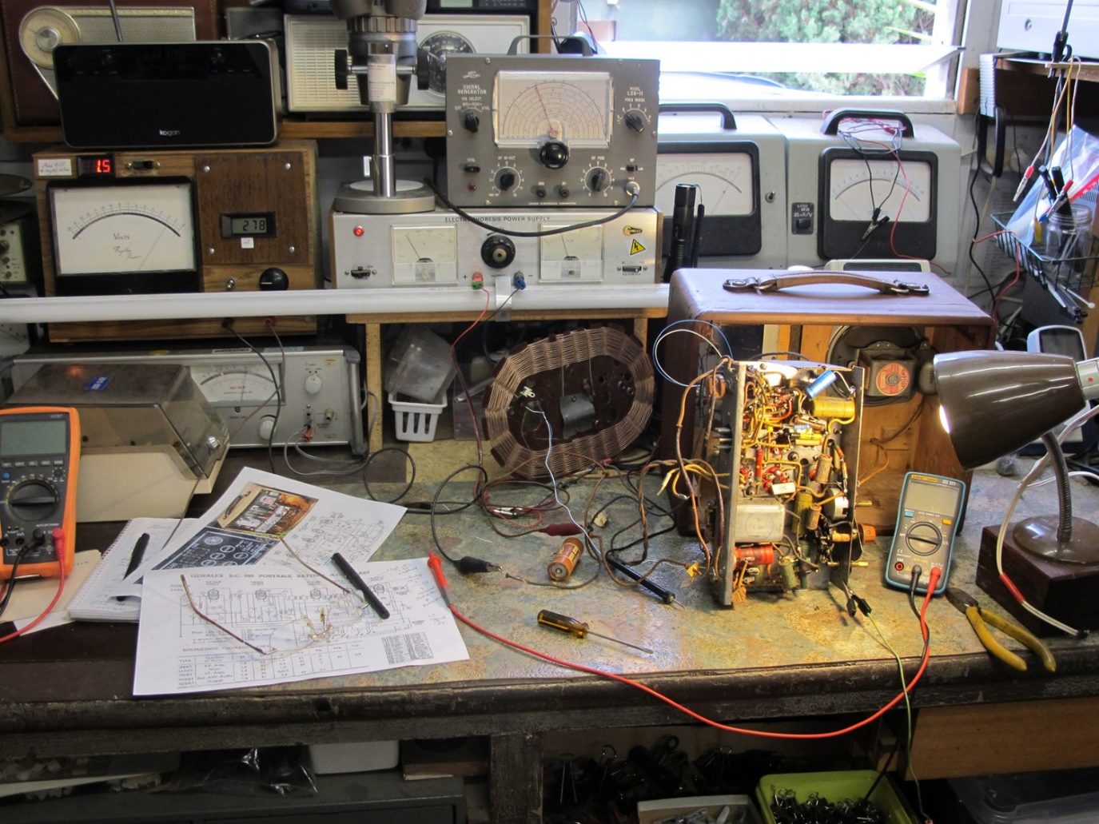

The case fabric presented poorly, even after rigorous cleaning and gluing the frayed sections back to the underlying ply. I have other portables using equivalent fabric in much better condition, so the whole case was painted brown to create a uniform surface. This sacrificed the original leatherette texture, but made for a more presentable radio that could be displayed rather than relegated to a storage shelf.

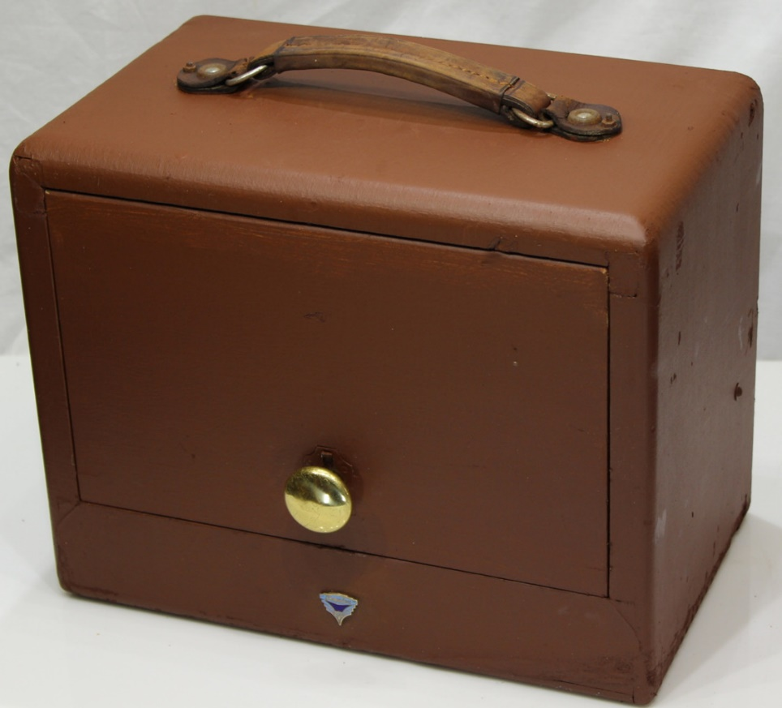
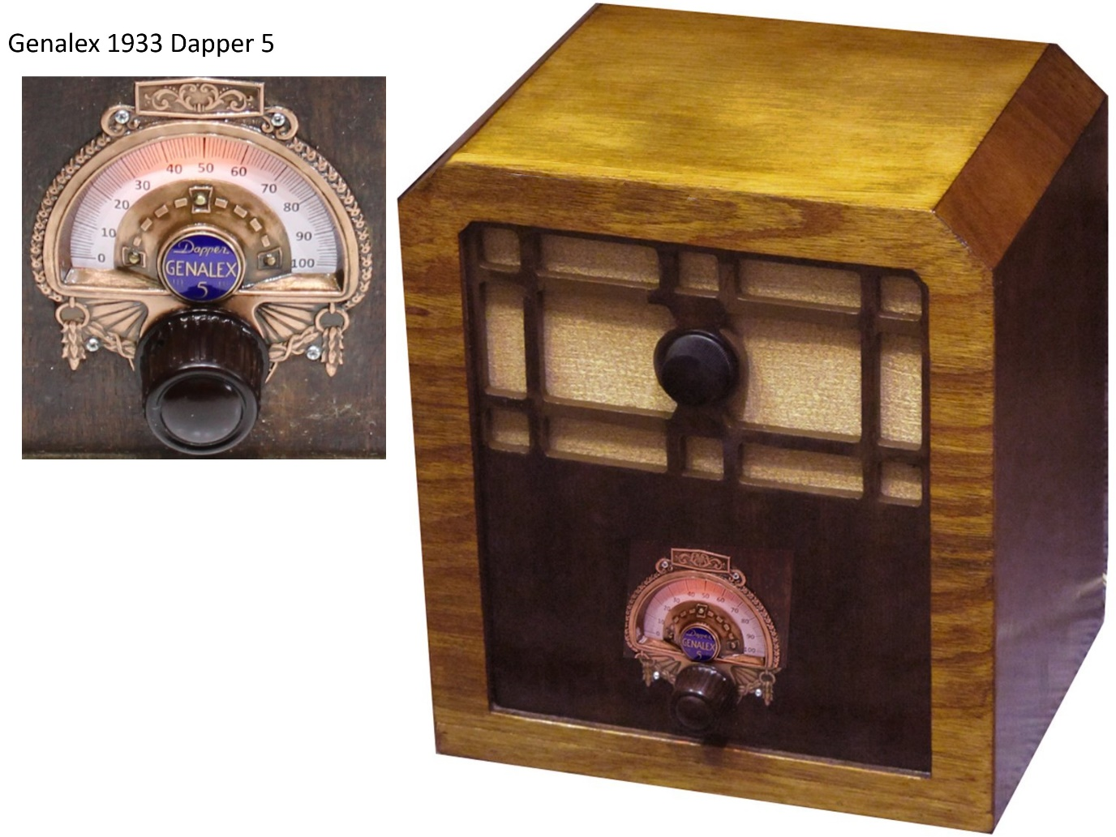

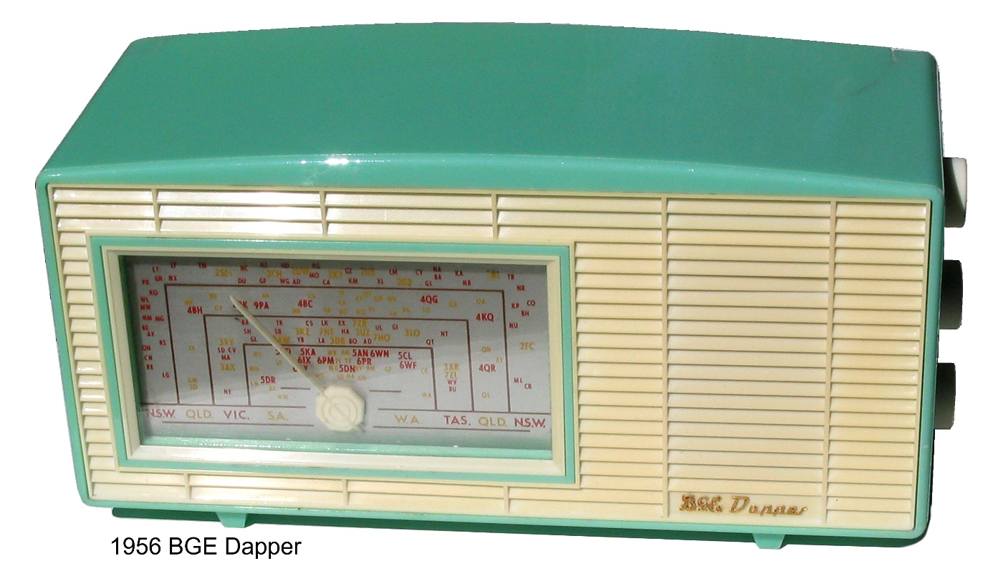

History of BGE
The General Electric Company (GEC as in GECOPHONE) rose to be a major UK-based industrial conglomerate producing consumer and defence products. From a small retail company in 1886 the company prospered through two world wars and amalgamation with Marconi. Eventually GEC was broken into subsidiary companies after 2001 (for details visit https://en.wikipedia.org/wiki/General_Electric_Company). At no time was GEC (UK) affiliated with the General Electric Company of America, a mistake in association that I had made before checking the history of the separate companies. General Electric (US) had a long time association with AWA marketing badge engineered AGE radios that were clones of AWA radios.
HRSA member Peter Hughes has posted the following summary of BGE in Australia at the European Radio Museum (https://www.radiomuseum.org/dsp_hersteller_detail.cfm?company_id=7723).
The British General Electric Co. started importing British made sets under the name of Gecophone from about 1924. After 1930 sets were manufactured by Thom and Smith Ltd (Tasma) under the name of Genalex. In 1933 the company made an agreement with Amalgamated Wireless Valve Co. Ltd. (AWV) for valves to be made with the Osram brand. The Osram boxes were marked "Made in Australia for the British General Electric Co. Ltd.". The brand used for radios was changed from Genalex to BGE in 1953. Between 1956 and 1962 BGE branded products were manufactured by Standard Telephones & Cables (STC).
Advertisements for Gecophone in Australia in 1924 proclaimed the head office address as 154-6 Clarence Street Sydney. Potential purchasers of a wireless to receive the new transmissions were told that radio would provide song, music and latest news and would form a necessary part of the day’s routine. The Gecophone radios sent to Australia were manufactured at the Coventry works (UK) which was “equipped with the most up to date machinery in the world”. Australian models were “minutely adapted to suit Australian regulations and conditions”. A 1924 complete Gecophone 2 valve radio with headphones cost £35. Evan Murfett has described and illustrated many of the beautifully presented Gecophone receivers of 1922-25 in Radio Waves in a five part series commencing in issue 146, September 2018.
The change from imported Gecophones to local manufacture was driven by high import tariffs imposed on radios around 1929. That import duty also affected US brands, notably Atwater Kent. The 1933 Dapper 5 Genalex is another Tasma product in my collection. The model 888 of 1946 featured here illustrates the ongoing BGE association with Tasma. The 1956 BGE Dapper represents the brand change to BGE and manufacture by STC. The Chassis of the 1956 Dapper is identical to the contemporary STC Bantam radio.
The Genalex radio featured here started off as a shabby old box, but every old box has a story to tell and this one has had some of its story told.

