Philips model 132
By Graham Parslow
The Philips Bakelite model 132 is among the last of the mantle radios made as a quality product before TV largely relegated radios to something for the kitchen. The circuit for the radio appears on page 257 of volume XIII of the Australian Official Radio Service Manual (AORSM) describing 1954 receivers, published in 1955. I have two examples of this model. The earlier one has dark knobs and the later one has white knobs. The give-away to the progression is that the earlier example has a Rola 6H speaker with a magnet that is square at the end with a decal style retained from the 1940s. The later radio has a speaker magnet rounded at the edge that was apparently introduced in 1955, as deduced from an advertisement on p6 of volume XIII of the AORSM. The style of the speaker decal also changed at this time and continued through to the mid 1960s when Plessey acquired Rola Australia.
The circuit
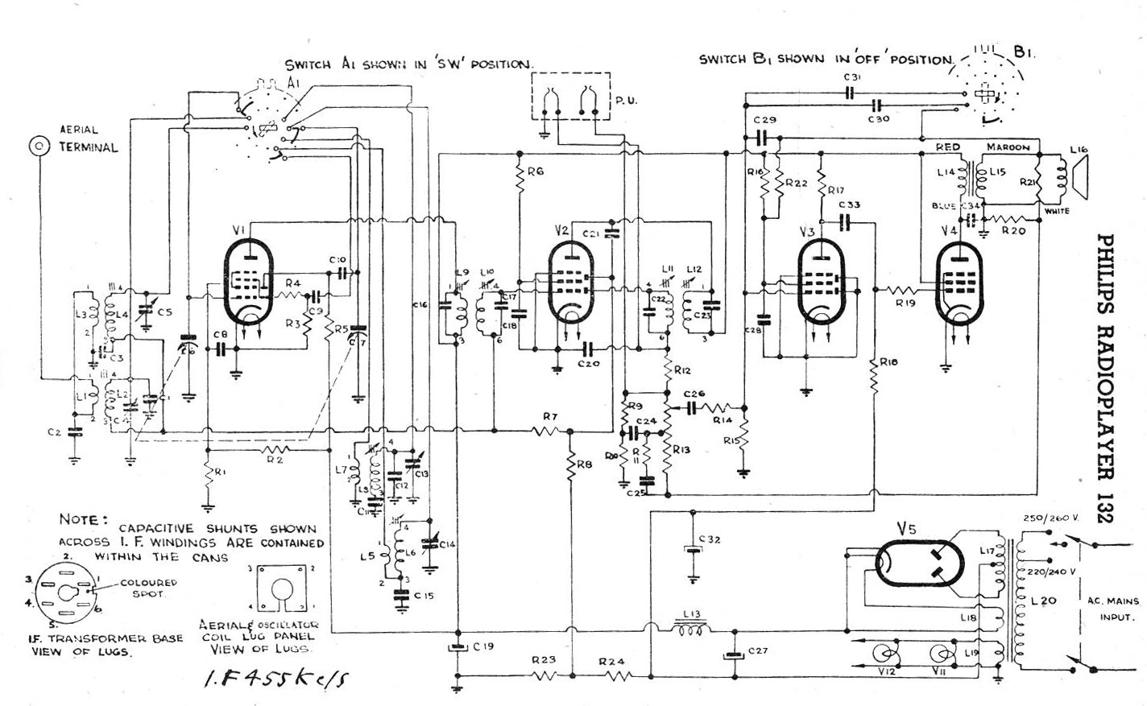
The front end is conventional with an external aerial coupling the RF signal through aerial coils that switch between broadcast and short wave (17.8 to 18.4 M Hz). The band select knob is third from the left. The frequency converter (mixer oscillator) is a 6AN7 with a normal plate voltage of 225 V. Then follows a 6N8 IF amplifier. Next is another 6N8 combining demodulation, AVC and audio preamplification. The output pentode is a 6M5 (plate voltage 210 V and screen 225 V). The HT rectifier is a 6X5, or an EZ82 in later production. Although the rectifiers have indirectly heated cathodes they are run from a separate 6 V winding from the mains transformer emulating the circuit of a 5Y3 rectifier. All of the valves have 9 pin sockets.
The centre tap of the HT from the mains transformer is fed to earth by resistors that provide negative grid bias, thereby allowing all cathodes to connect directly to the chassis. The presence of a 10 µF 40 VW electrolytic capacitor, normally a cathode bypass, was puzzling until the circuit diagram showed this as C32 filtering the bias voltage.
The tone control circuit is rudimentary with two switched positions that vary the amount of top-cut. The switch is designated B1 and also incorporates the double pole mains ON-OFF switch. As manufactured, the mains cord is two strand figure-of-eight that easily slides into the slot cut into the backing cover, unlike replacement three core cables.
The volume control R13 restricts the signal applied to the grid of the 6N8 preamplifier. The volume potentiometer also has a tap feeding a circuit to enhance base frequencies. The result is a mellow audio output of agreeable listening quality for AM broadcasting.
The story of the dark knob radio.
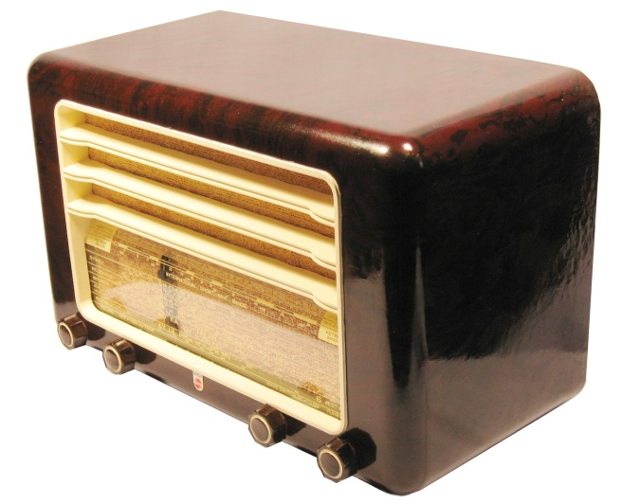
This radio was purchased from eBay in 2010. The first impression was that this is a sturdy radio. The one piece Bakelite case is remarkably thick. The grille is integral to the case and is painted to achieve contrast. This radio had areas of missing grille paint revealing the dark Bakelite below. Fortunately Motortech brand Heritage Cream spray paint is a good match to the colour. This paint can be purchased from Autobarn, or contact the manufacturer at mmpindustrial.com.au.
The back of the radio has a pressed cardboard panel allowing some ventilation. There is also access to the aerial connection-post and the pickup terminals located on the chassis.
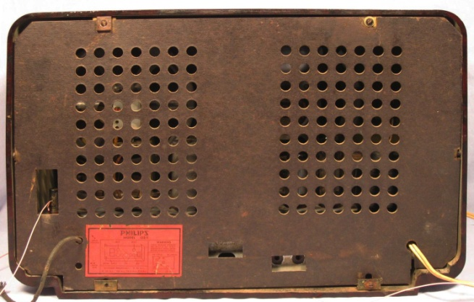
The presence of the backing board had minimised the accumulation of dirt and grime over the internal components. However the chassis showed rust in patches, as can be seen in the front view of the removed chassis.
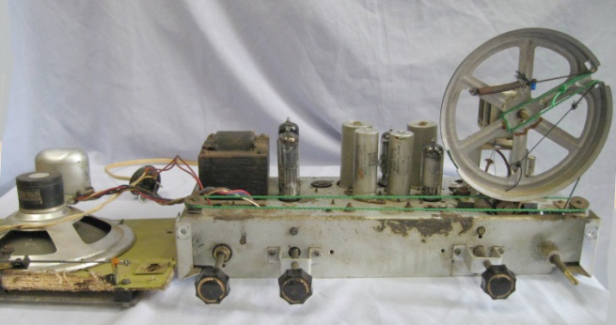
Disassembling many Philips radios is a chore due to the way in which they have numerous interlocking modules. Happily this one is largely modular and the whole assembly slides out after undoing three screws that fix the speaker baffle to the case and four screws holding the chassis to the bottom of the case. The dial string had broken before I acquired the radio. An intrepid repairer had used some green string to somehow restore function, but certainly not by the original pathway. The tuning condenser is one of the semi-miniature types with brass plates that Philips used through the 50s and 60s. This small tuning condenser makes the large dial drum seem even bigger. That dial drum is flimsy and if it is warped, as it can be with a casual knock, the dial string comes off. The tuning is easy to set a precise lock onto a station because of the low gearing of the tuning spindle to the rotation of the drum. A down side is that lots of turns are needed to tune from end to end. The long travel of the tuning indicator also allows for an uncluttered marking of stations on the dial. The stations are easily read because of the large font. The side illumination from the dial lamps also helps to make the stations more readable.
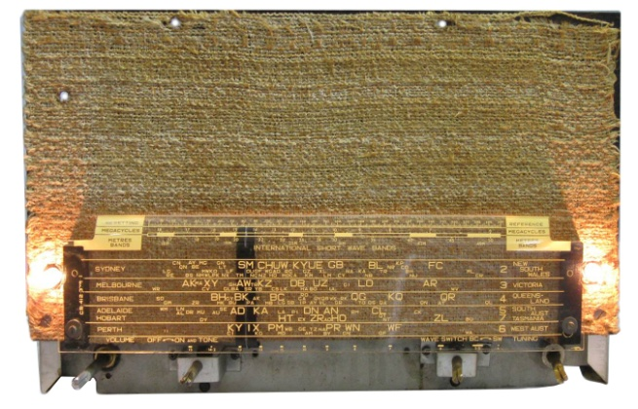
The speaker baffle including the dial is attached to the chassis by two screws at the front. Before swinging the baffle and dial assembly away from the chassis it is necessary to unscrew the pointer clamp to release the pointer from the dial string. Even so this is one of Philips less intimidating disassembly operations.
This radio was not working as received. Excessive current was being drawn and the primary HT was down to 85 V. The audio transformer was heating and this provided a clue. Removing the 6M5 pentode should have stopped this current drain, but it made little difference. Additionally the speaker continued to crackle (usually impossible with no output valve). Inspection of the area around the 6M5 revealed the strange sight of an unrecognisable component.
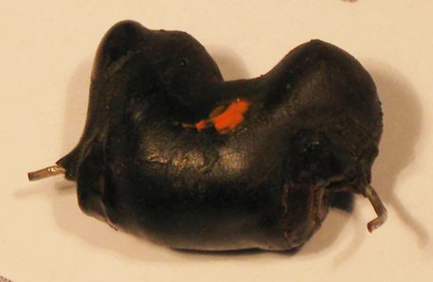
The circuit showed that this blob occupied the space assigned to C34, a 0.02 µF 400VW capacitor. The function of this capacitor is to act as an uncoupler of interference at the output and it is connected between the plate (nominally 210 V) and earth. The blob had a measured resistance of 200 ohms between the pigtails, so all was revealed. C34 had failed under high voltage and melted the pitch covering. It connected HT to earth via the primary of the output transformer. This load dragged the HT down to 85V. A replacement capacitor restored function, thankfully with the audio transformer still intact. I subsequently found the equivalent to this capacitor had failed in other Philips radios so I am attuned to this fault.
The story of the white knob radio.
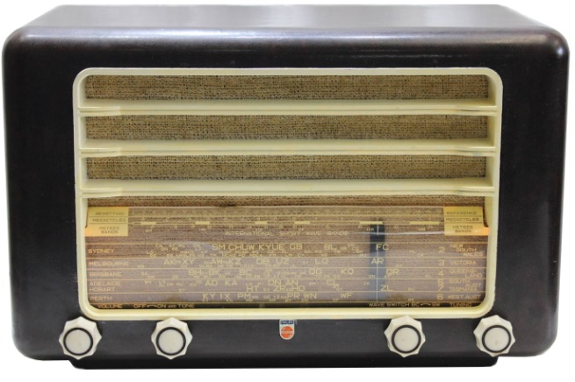
2016 has been my first year of retirement and my wife and I spent half the year travelling the nation in our caravan. Our travels brought us to visit my cousin Paul in Penguin, Tasmania. Tasmanians now have little use for AM receivers because the ABC is almost the only AM broadcaster and the coverage is patchy. This radio had been in the family since new. It was stored away in a shed due to having little practical use, an unremarkable appearance and a broken tuning cord. Paul gave the radio to me to restore and keep for heritage. I am duly appreciative of his generosity.
The first step was to paint the spotty grille with Heritage Cream then polish the faded Bakelite case. The evidence suggested that the radio had been in bright sunlight for a long time. Even so it polished up well.
Before turning the radio on, the chassis and components were thoroughly cleaned. The dial cord was restrung and this was not an easy task. Even with judicious clamping it is a major challenge to maintain enough tension in the string to successfully keep loops on the drum while negotiating the maze of double pulleys and under chassis looping to the tuning spindle. My eventual happiness was all the greater for the degree of difficulty.
Looking under the chassis immediately showed a highly dubious joint between C26 (0.02 µF 400VW) and R14 (47K ohms).
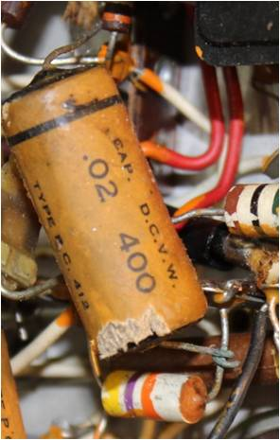
The capacitor was indeed correctly connected in its place in the circuit, although the copper-nickel corrosion may have made for intermittent contact. It also looked like some insect had sampled the case of this capacitor so it was replaced and the new capacitor properly soldered into circuit. My guess is that the capacitor had come away from its post due to corrosion and the corroded end was then simply wrapped around the resistor pigtail.
The first power up was simply to test the mains transformer with no valves installed. The two dial lamps came on and power consumption remained at a stable 7W. With its valves installed optimism for immediate gratification was rewarded when the radio came to life. A dropout of low frequency stations was easily fixed by correcting some plate contact in the tuning condenser.
Power consumption was 51W at first switch on. A check of the HT at the first filter electrolytic showed it was about 35 V low at 190 V. The 6M5 grid measured 0V relative to the chassis. The AORSM data for this model indicated that the bias should be around negative 6 V. The solution was to replace the slightly leaky C33 that coupled the preamplifier to the 6M5 and also reduce R18 (1 Megohm) to 220K. The 6M5 bias was restored to a comfortable negative 5 V and significantly reduced conduction through the 6M5, so much so that HT rose to its nominal value and power consumption decreased to 40W. The radio was now ready to resume faithful service.
The under-chassis picture shows the final appearance of the radio with a three cord power lead replacing the original twin flex.

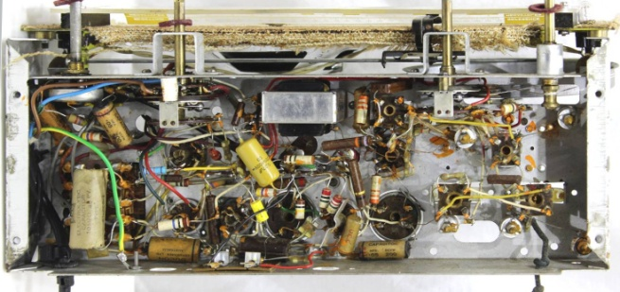

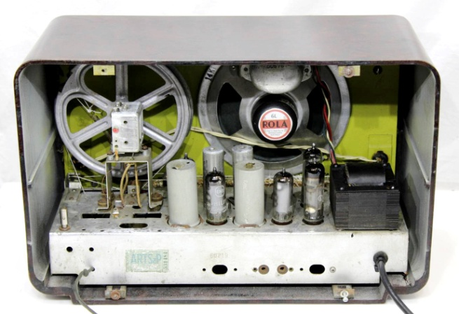
These radios are solidly built and excellent performers. It is one of the vagaries of fortune that they have not achieved the collectability that many lesser radios have.

