Sound recording for business and pleasure by Graham Parslow
This article features many technologies that I have grown up with. The illustrations are in large part of items in my collection. It is not intended as a comprehensive review of recording.
Recorded sound is now so ubiquitous that it takes a leap of imagination to go back to the times of Beethoven and Mozart when the only way to hear music was to assemble some musicians. Then in 1887 Thomas Alva Edison devised a way to record a pattern of grooves that was an analogue of sound and could be played back. Humanity was hooked on recording and listening to recordings. Radio subsequently became a way of sharing those recordings with anyone who cared to tune in.
There was a time when most radios were just single function. Radios were in the kitchen, the shed and were part of the lounge entertainment system. In 1980 I upgraded our kitchen radio to a modest boom box, the Philips D8343 radio tape player.
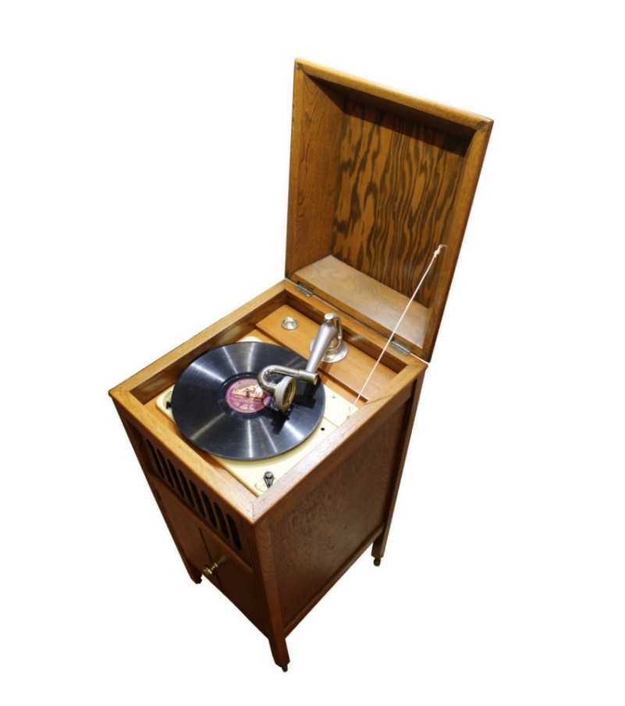
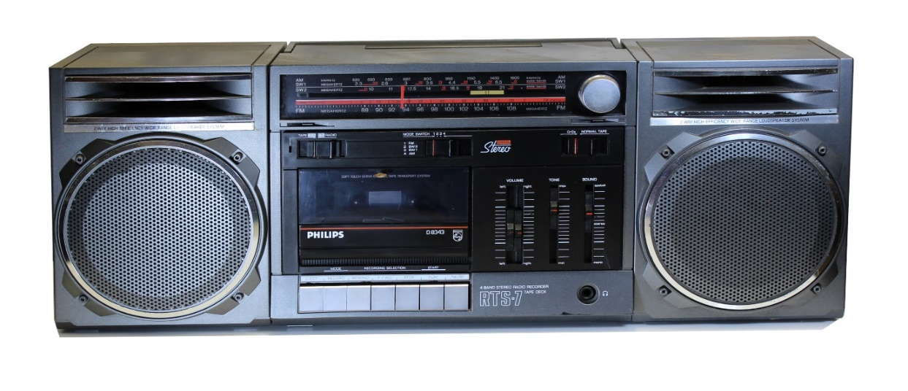
In 1980 the phenomenon of discount electrical retailers was yet to become common. I was living in Adelaide and a new store called Cunningham’s Warehouse opened offering previously unheard-of bargains. I could not resist this one. Neglected for many years the D8343 now resides among my display-collection of radios. Iin October 2024 it was taken down and nostalgically revived to recall its many years of good service.
It also played many cassette tapes in its time, but no longer because the take up spool has no tension and tapes are converted into a tangled mess. This work-horse radio of days gone by resides close to a Gloriola mechanical gramophone that plays 78rpm records. The Gloriola harkens back to when recording began.
The Edison business phonograph evolved soon after his 1887 invention. It was composed of an executive dictating machine and a secretarial machine for transcribing to text. The recording medium was a wax cylinder. Recently the HRSA was given a Dictaphone (circa 1930) courtesy of the National Trust as a result of them clearing some storage space. That Dictaphone is far from pristine, but takes us back to the period before WW2 when magnetic recording was not practical for office dictation systems.
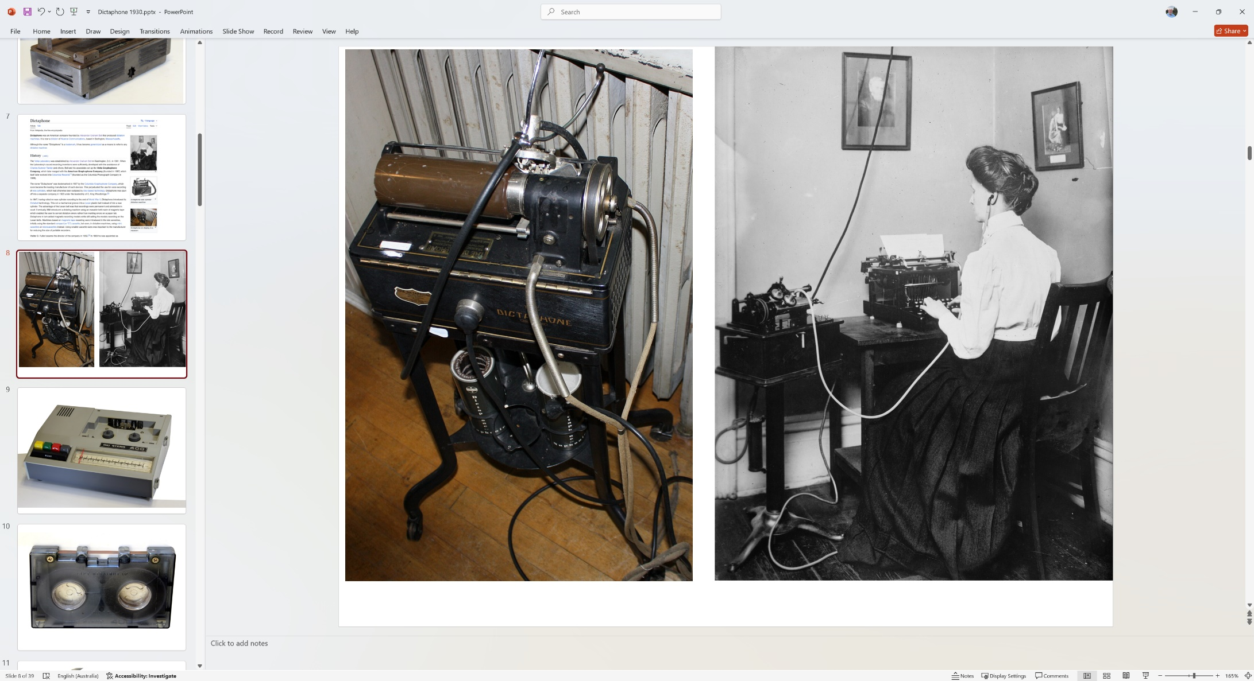
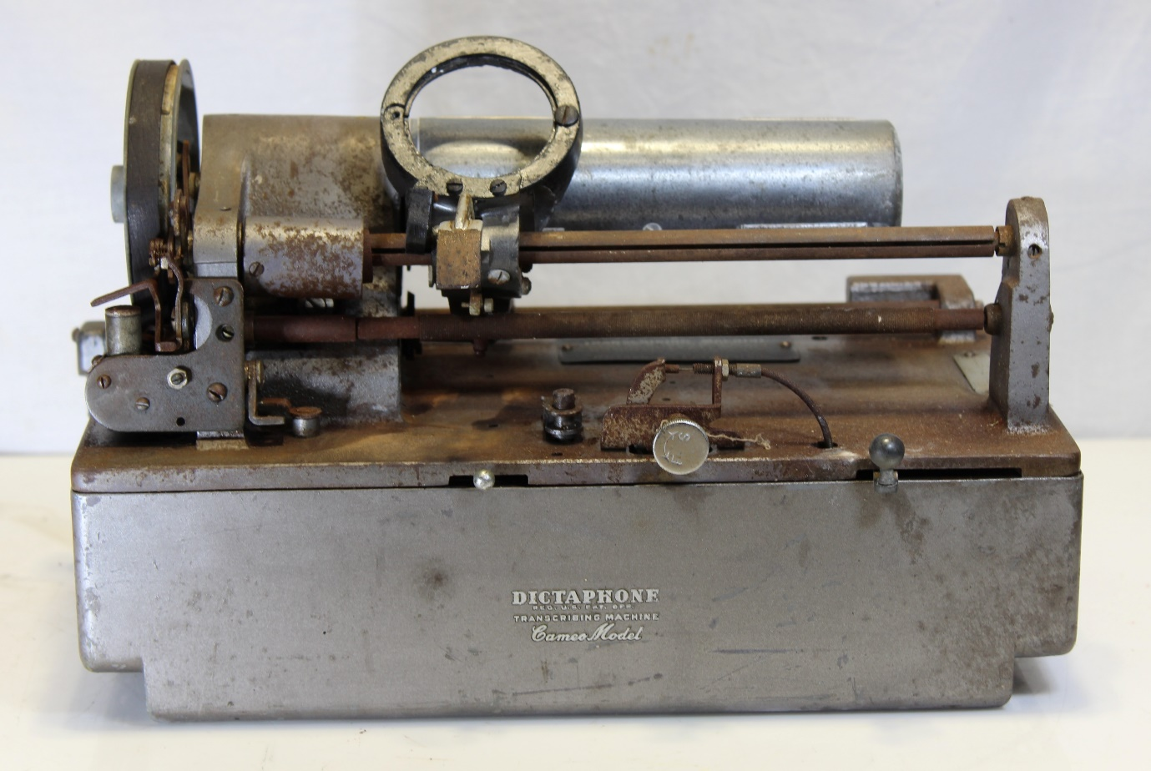
The pictures of a Dictaphone and a secretary at a typewriter comes from Wikipedia https://en.wikipedia.org/wiki/Dictaphone.
The name "Dictaphone" was trademarked in 1907 by the Columbia Graphophone Company founded by Alexander Graham Bell, which soon became the leading manufacturer of such devices. This perpetuated the use of wax cylinders for voice recording, even when music had moved to disc-based technology.
Far superior to wire recording the Germans developed tape based magnetic recording during WW2. This changed the post war sound recording technologies, but not as rapidly as you might have thought. Dictaphone added magnetic recording models while still selling heritage models.
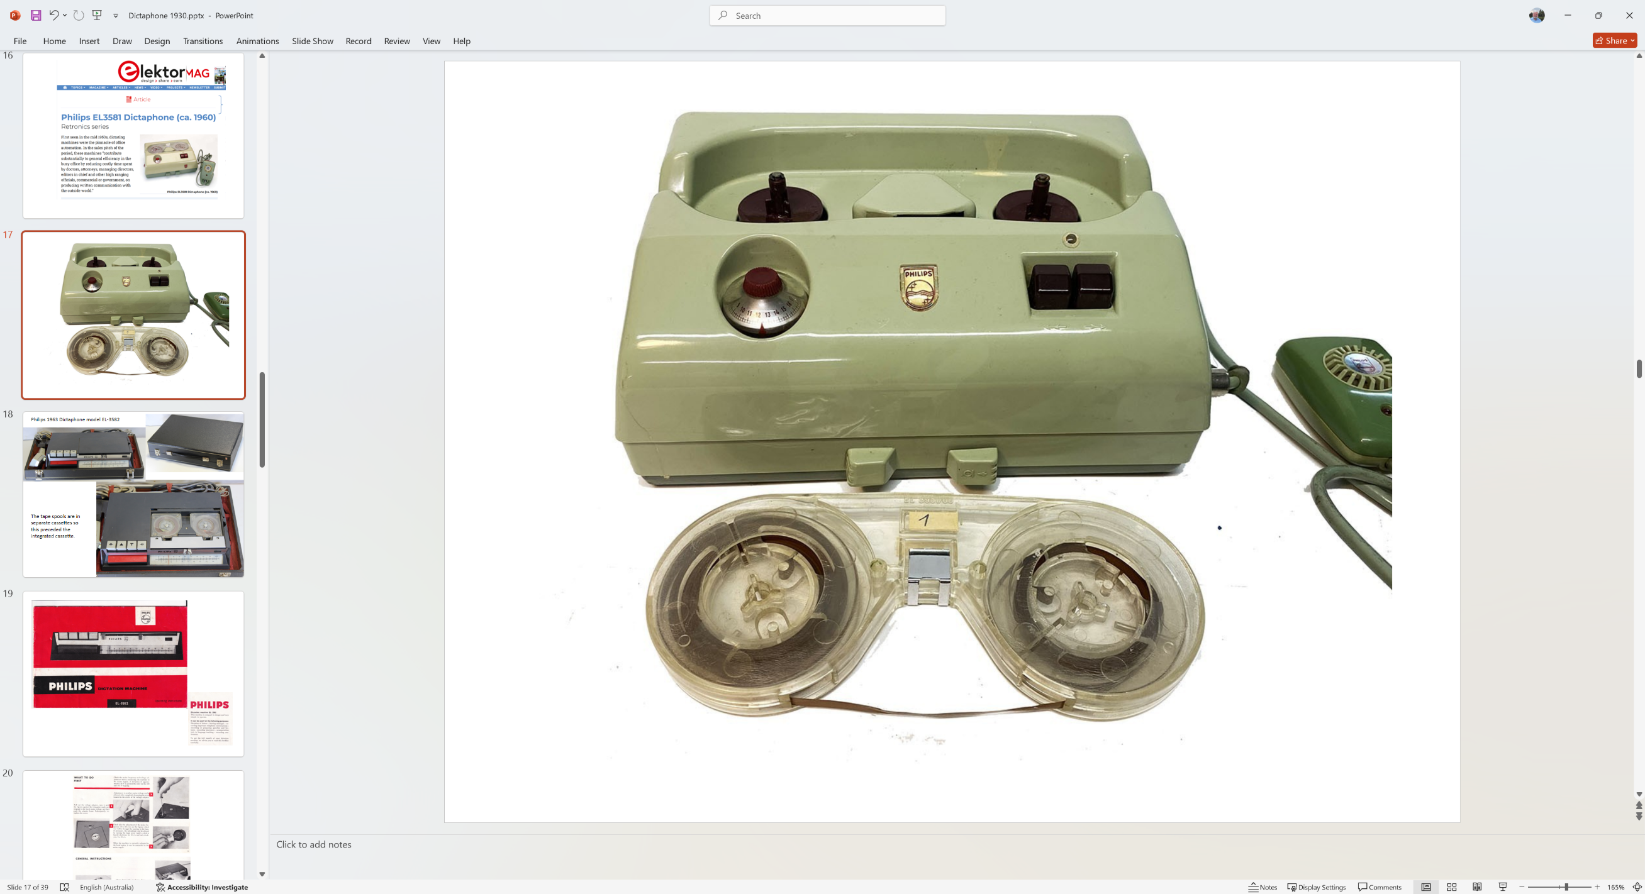
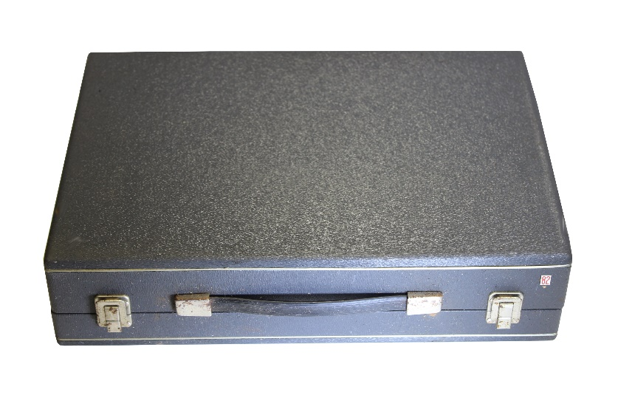
In the 1950s Philips offered the EL3581 dictation machine with a post-war period look. Philips had learnt how inept many office workers were with threading spools on reel to reel recorders, so the EL3581 featured a one-piece cassette. The hub spindle featured the same triple lug used on reel to reel machines. By 1960 the EL3581 left a bit to be desired aesthetically.
In 1960 the successor to the EL3581 was the far more elegant EL3582 and I have one of these dictation machines in my collection. The presentation and storage box has a real touch of class with felt lining.
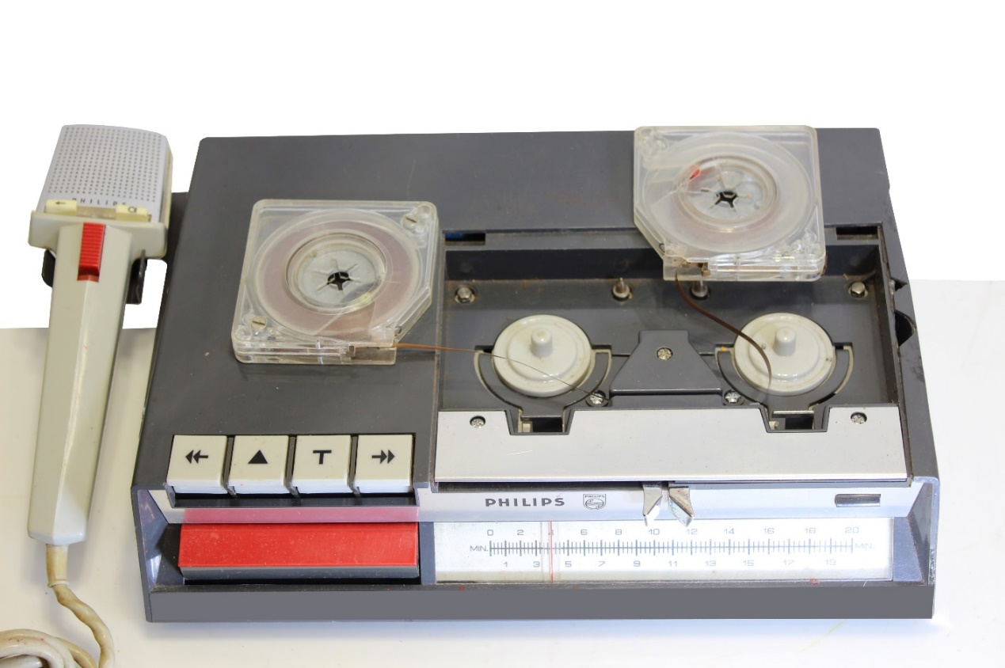
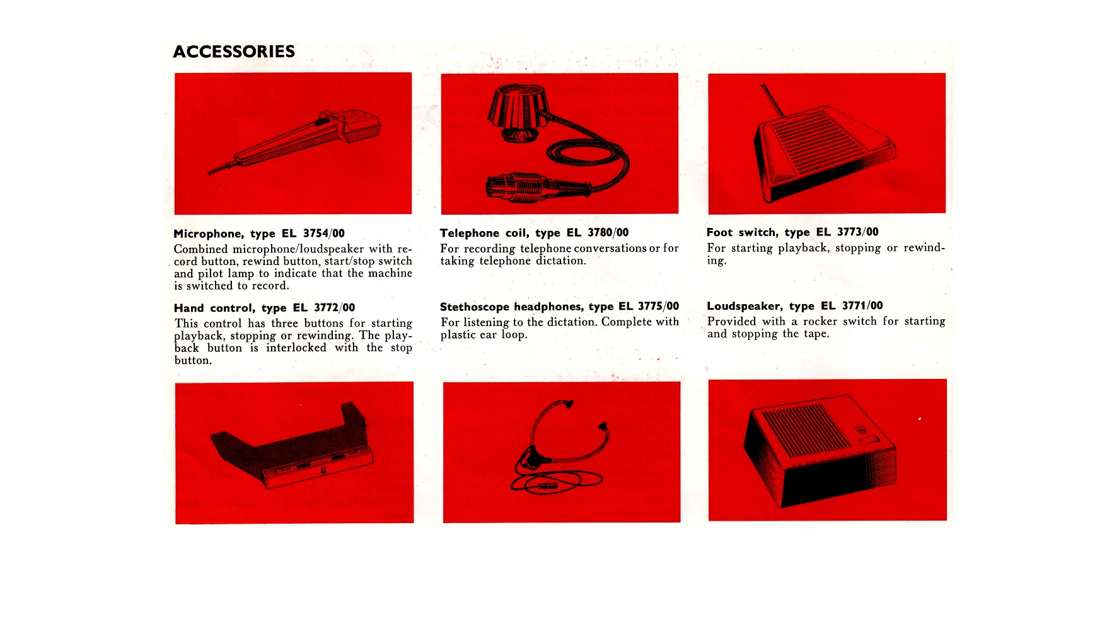
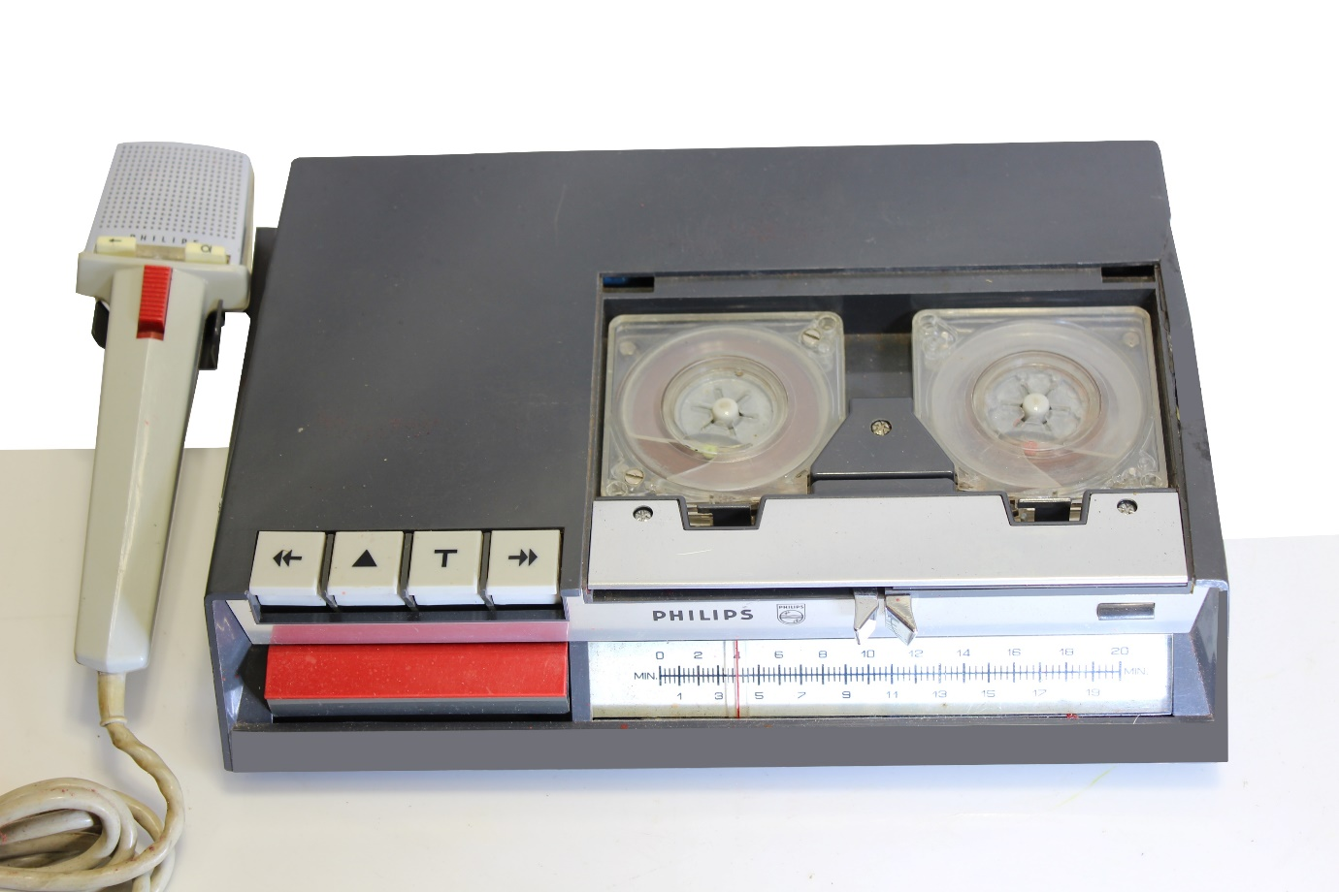
A surprising backward step was to house the tape in separate cassettes that are rather tricky to thread without mangling the tape. The EL 3582 was highly accessorized. Everything needed for convenient start-stop recording and editing was included, or optional.
It is now time to introduce Lodewijk Frederik Ottens (21 June 1926 – 6 March 2021). Ottens was a Dutch engineer and inventor, known as the inventor of the cassette tape and for his work in helping to develop the compact disc. As a teenager during the German occupation of the Netherlands in World War II he constructed a radio that he used to secretly listen to prohibited broadcasts. In order to avoid Nazi jammers Ottens constructed the radio with a directional antenna. In 1952 Ottens was hired by Philips where he worked at producing turntables, tape recorders, and loudspeakers. In 1960, Ottens became the head of the product development department. In this position he led the development of Philips first portable tape recorder, the EL 3585 that sold over 1 million units.
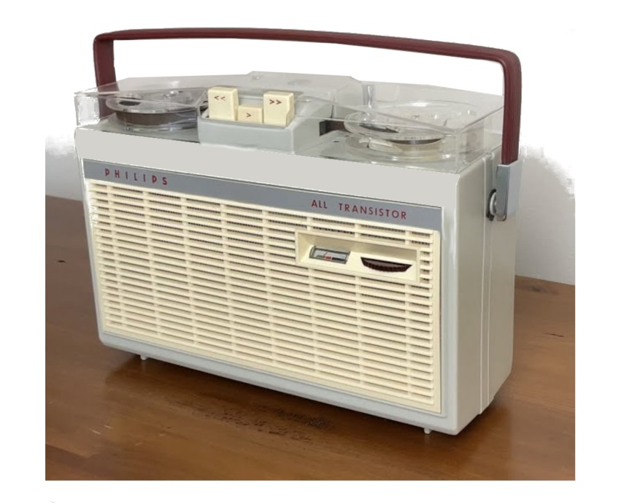
Building on the success of the EL 3585, Philips aimed to produce a "pocket recorder," to be inexpensive and small, with low battery consumption but offering reasonable sound quality. Originally, Philips planned on working with RCA and using the RCA tape cartridge system, but Ottens found the dimensions and tape speed unsuitable.
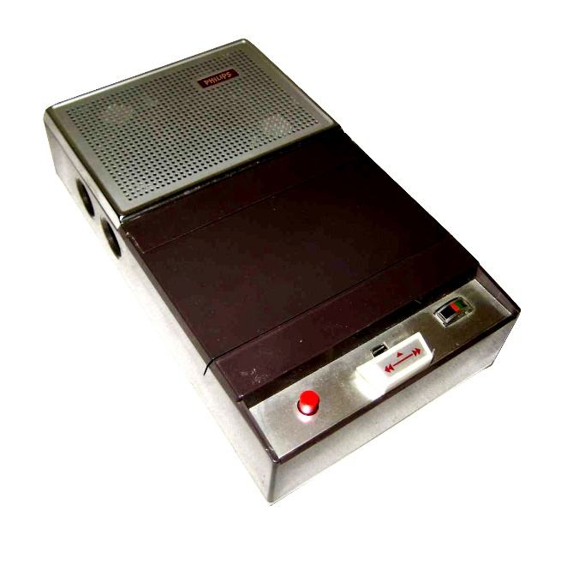
Ottens decided to develop his own cassette. He started the design of the cassette by cutting a block of wood to fit into his jacket pocket. This wood block would become the model for what became the first portable cassette recorder, the EL 3300. The basic shape of the EL3300 was subsequently copied by numerous other manufacturers. The modest specifications of the EL3300 included a frequency response of 120 to 6,000 Hz.

The EL3300 using the Ottens cassette system was launched in 1963, but failed to spark much interest in the audio world. However, some photos were taken of the system, which led to the production of Japanese cassette-based recorders using larger cassettes than the Philips. That includes the OKI cassette shown later. One reason for Philips ultimate triumph with the Compact Cassette, was that they offered their cassette design royalty-free to other manufacturers such as National and Sony. This led to the Compact Cassette becoming the world standard.
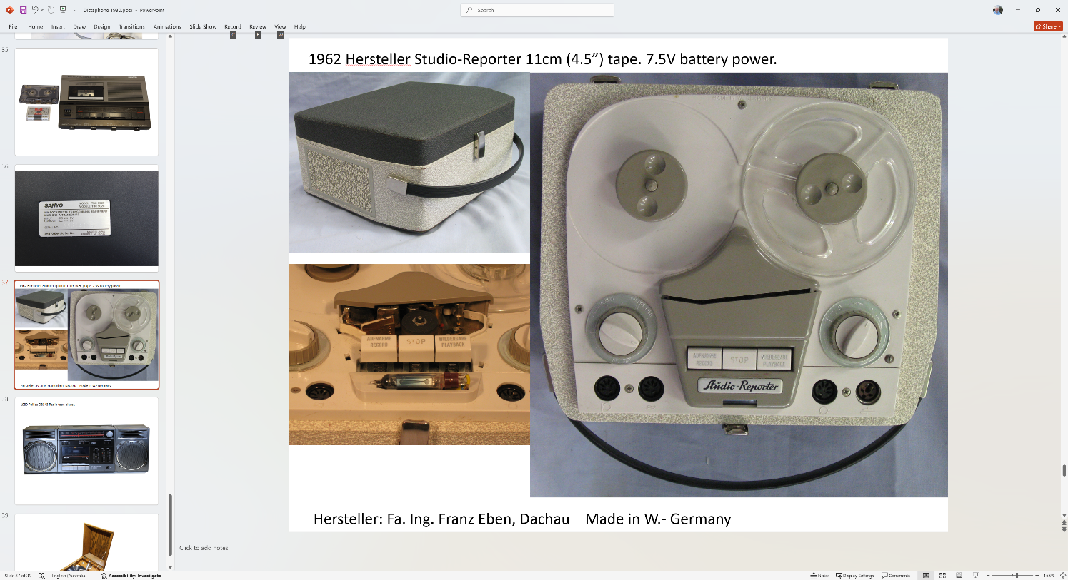
Meanwhile most manufacturers were staying with reel to reel for both mains powered and portable recorders like the 1962 Hersteller Studio-Reporter with 11cm (4.5”) tape and 7.5V battery power. The example shown here is in my collection. It is solid state although it has a valve magic eye level meter.
1963, the release year of the compact cassette, was also the year my family purchased a Philips model EL3541-OOM reel to reel recorder. I was 15 years old. This was my primary source of recorded music until purchasing a SONY TC-255 deck in 1970 when I was 21 years old. My TC-255 tape deck was coupled to a Sansui AU-101 amplifier driving Magnavox speakers in a home-constructed enclosure made to an RTV&H design. Most serious hifi people were buying reel to reel recorders in 1970, but the specifications for cassette players were rapidly improving.
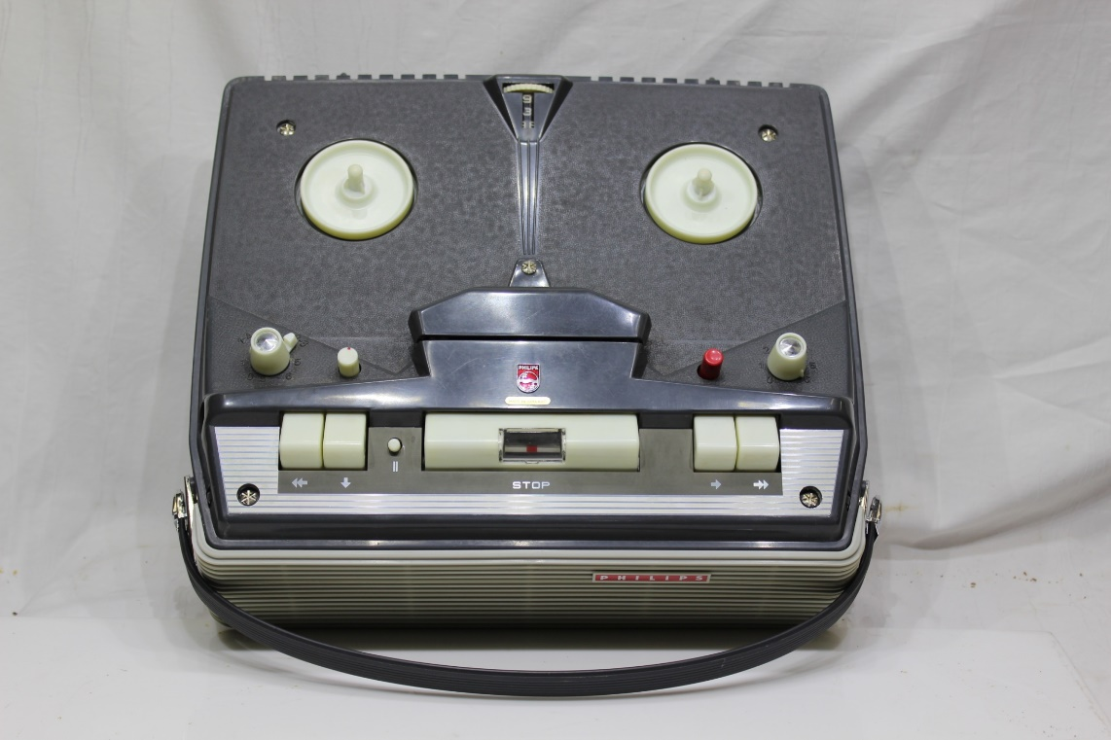

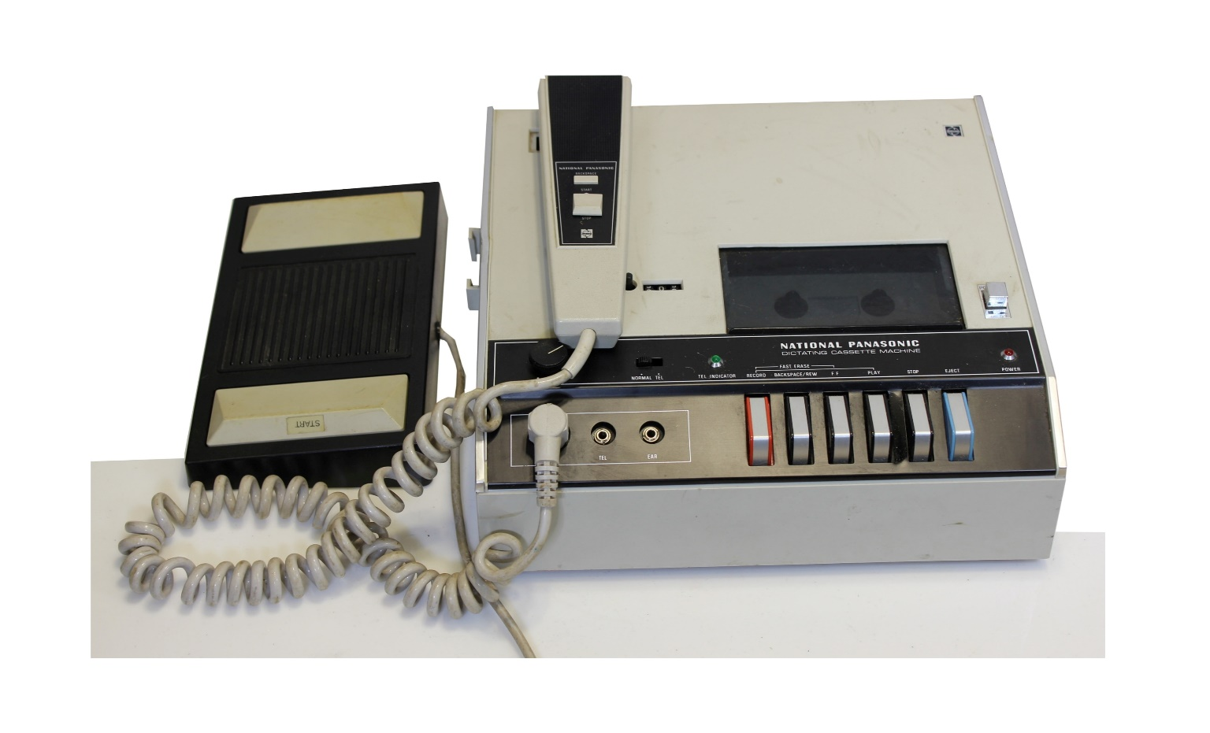
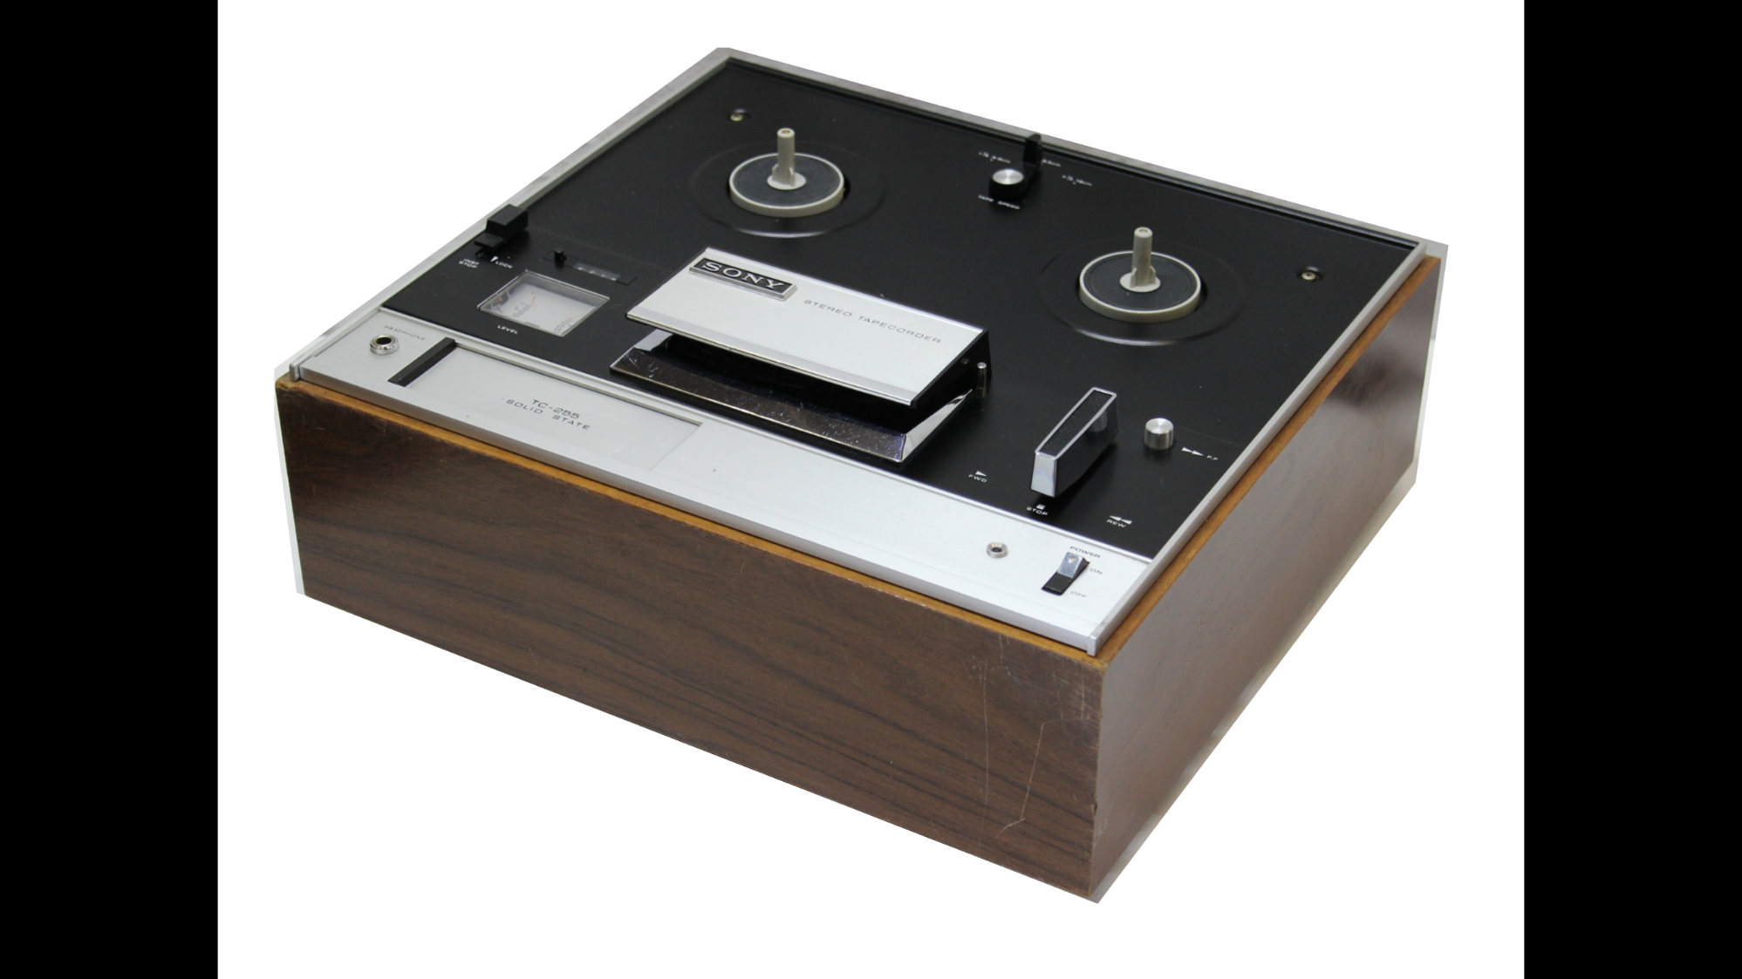
Some business dictation machine manufacturers adopted the standard compact cassette, like for the National Panasonic RV2005S in my collection

Despite the standardization introduced by the Philips cassette, some manufacturers of dictation machines took to using mini-cassettes or microcassettes. Smaller cassettes were important for reducing the size of portable recorders at a time before circuitry shrank into integrated circuits. I have this Sanyo TRC-5020 Memo-Scriber in my collection, shown with a standard cassette for comparison to the SONY microcassette that it uses.
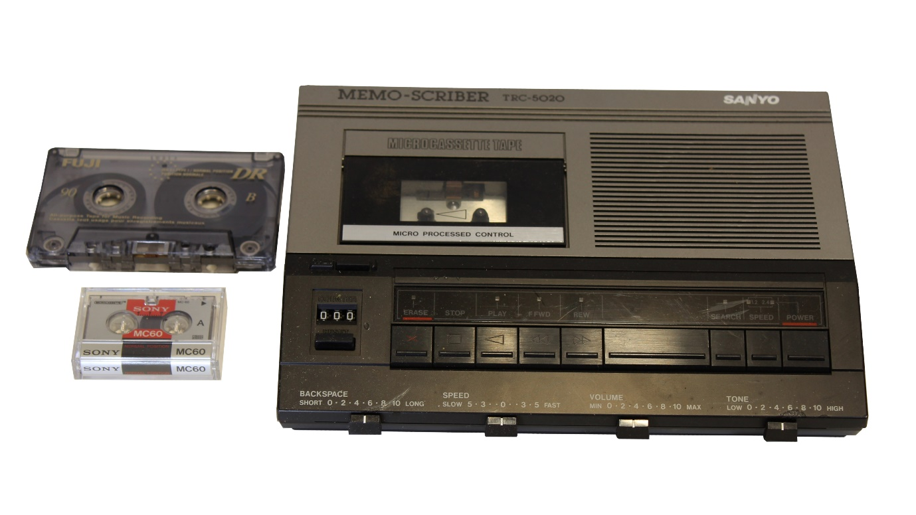
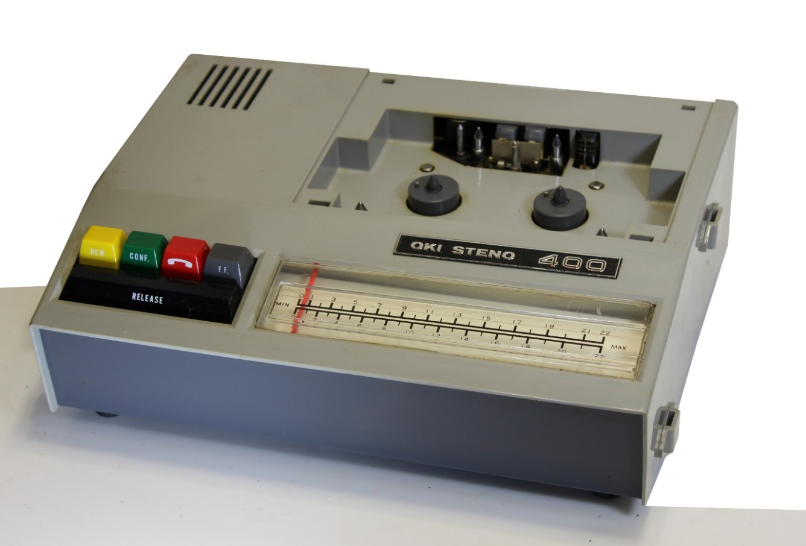
In Japan, JVC released the picocassette in 1985 which was even smaller than a microcassette while offering good recording quality and duration.
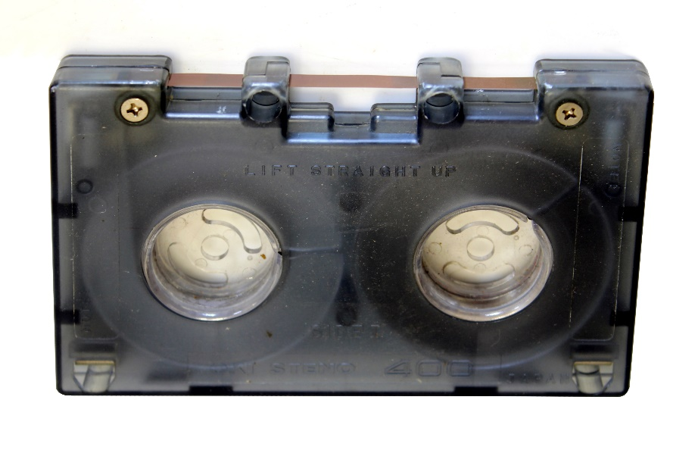
The 1969 OKI Steno-400 in my collection bucked the micro trend with a larger than standard cassette using ¼ inch tape. OKI is a large corporation specializing in office products, notably printers.
The US designed 8-track cartridge system released in 1964 is worth a brief mention as an alternative to cassettes. 1978 was the peak year for 8-track sales. I had an 8-track player with my car radio from 1975 to 1982 and recorded to cartridges with a Tandy 8-track deck. The demise of the 8-track format was rapid. By the mid-1980s 8-track was no longer supported by manufacturers like Ford that had been a major adopter. I changed my car radio to a Clarion-branded unit that incorporated a cassette player.
For the domestic market SONY developed the ultra-compact Walkman. It used a standard cassette and was released in July 1979. I have two Walkmans in my collection, one has an internal speaker (model K989) and the other requires a headphone (model WM-FX313)
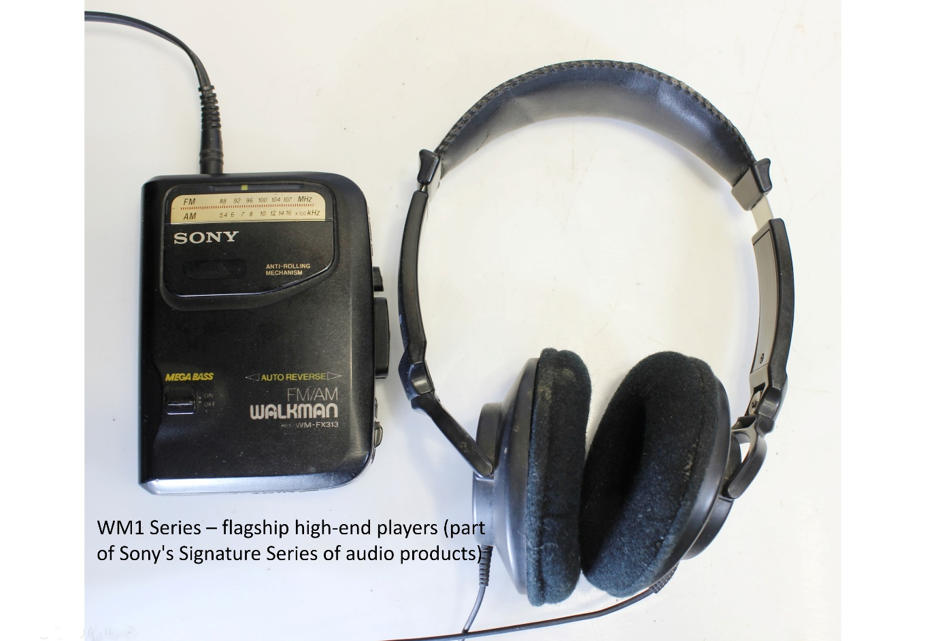
In the 1980s the technology to manufacture VHS video recorders made its way into high-end reel to reel tape recorders, just as the reel to reel format was being abandoned. Happily, I have a 1981 Akai model GX-747 that incorporates this ultimate technology. It has remarkable specifications including a frequency response of 25 to 33,000 Hz. Rather than the one in my collection I have chosen to show an impressive image of the GX-747 from an Akai promotion of the recorder.
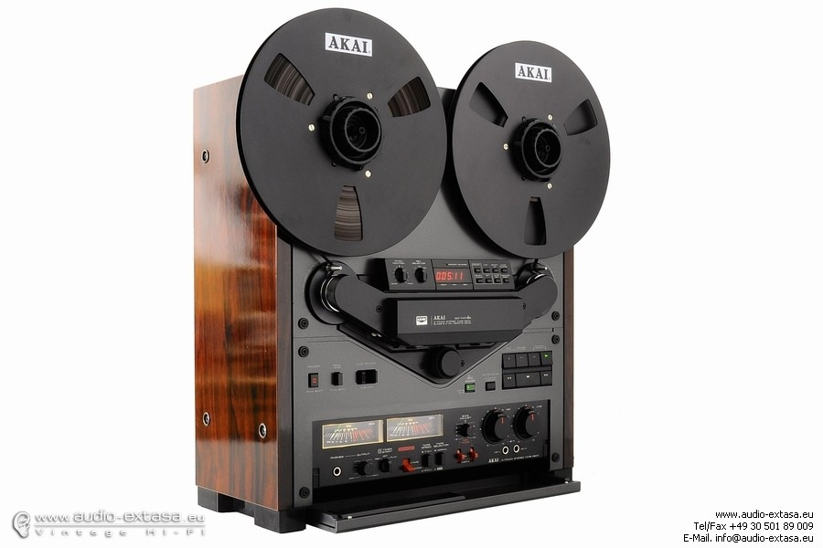
Optical and digital technologies were introduced to domestic markets in 1982 when the Philips-SONY CD format was released. The optical medium was extended to DVDs in 1997. Audio cassettes lived on into the 2000s in both mass player units, and hifi decks for audiophiles.
Beginning with the rather ordinary EL-3300, cassettes evolved through top-loading single-tape hifi units to double-cassette front loaders.
An end-of-the-line cassette deck in my collection is the Pioneer model CT-W530R that I continue to use. The Pioneer deck includes these specifications. Frequency Response: 25Hz to 18kHz (metal tape), signal to noise ratio: 76dB (Dolby C) and wow and flutter 0.055%. This is rather good for a mechanical analogue system based on1/8 inch tape.
Sadly, many of the rubber drive belts in my other cassette tape players have become unserviceable.
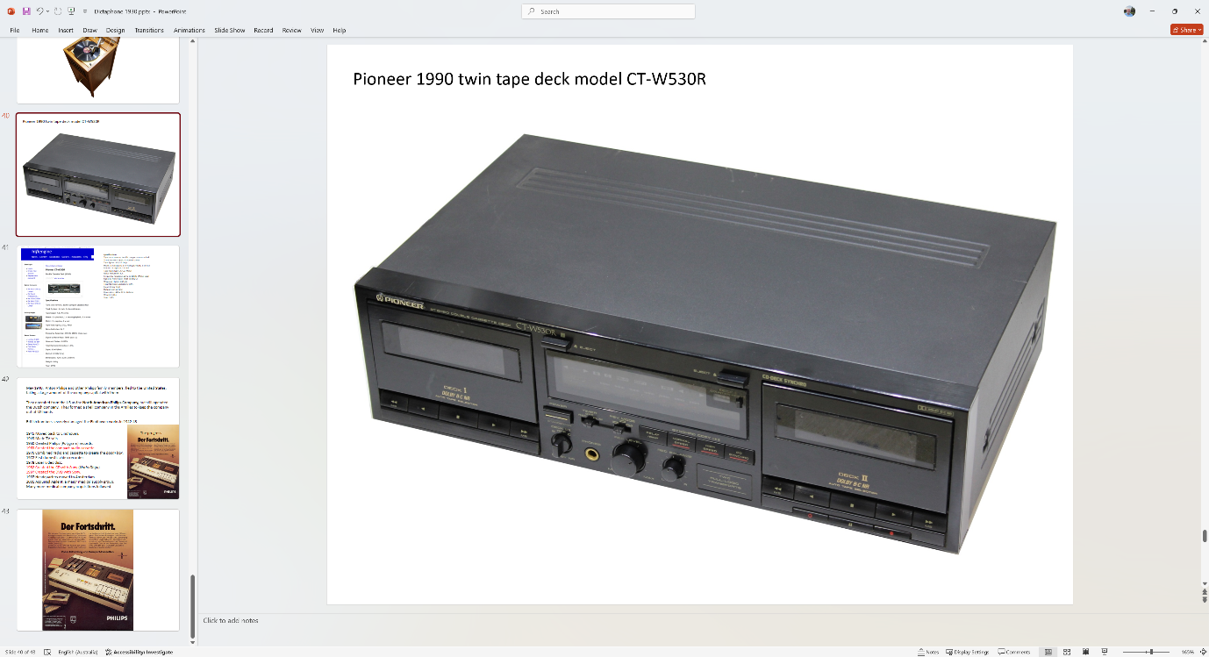
The story could continue through CDs, DVDs, BluRay and solid state digital devices, but maybe another time. If you are wondering just what sort of other radio and hifi memorabilia I have collected you can see images of my treasures at the web site hrsa2.com.

